How it works
"Drop in" easy mounting.

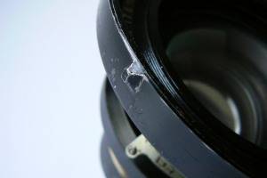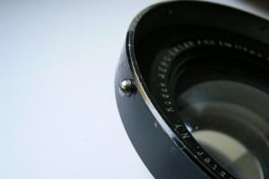

Originally the Aero lens was produced with two different lens surrounding bezels.
On the left photo the Aero lens surrounding bezel with notches and on the right photo a bezel with screws.
Both types are compatible to attach the JoLo 70 mm Lens Hood.
This new indispensable JoLo Professional Lens hood. Filters can be placed on front or backside of the hood. The lens hood made out of light 4 mm aluminium fits perfectly to the Kodak 7 inch Aero lens.
Including knurled nut attachment and hex fixing screw.
The integrated filter holder is part of the lens hood which has been manufactured out of one piece of aluminium.
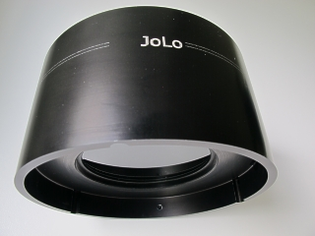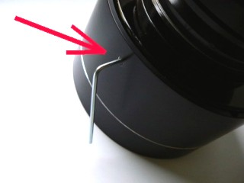
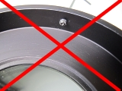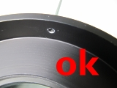
The lens hood slips easily over the original Aero lens mount and drops exactly on its place. The lens hood can be fixed to the Aero mount with the Allen hex screw. Please make sure the Allen screw or Hex screw does not protrude on the inside when slipping the hood over the Kodak shade. Once the shade has found its place on the Kodak shade, you may turn the Allen screw tight to fix the hood to the lens. It only takes a few seconds to mount the lens hood, ready to protect your exposures for stray light.

Integrated Filter holder

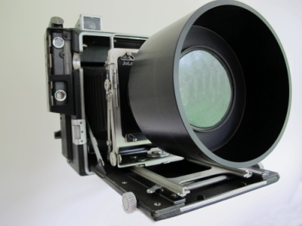
INDISPENSABLE
Even when using a very slow film you won't be successful with the Aero lens wide open in bright daylight.
If you don't shoot wide open, you will miss the special effects which makes this lens so spectacular and exclusive.
Luckily there are special 77 mm ND filters on the market. They will reduce the light in such a way that you'll be able to shoot the way you want it: with the lens wide open!
To mount these indispensable filters, this special JoLo Lens Hood has been developed. You won't find a better and more effective solution.
The JoLo 77 mm filter holder is integrated in the JoLo lens hood right in front of the Aero lens and the 77 mm filter can be easy mounted on the front as well as on the back side of the lens hood.
The 77 mm mount accepts all available 77 mm filters including circular polarization filters.
Decreasing the depth of field by allowing wider apertures to be used, in turn helping to separate subjects from their background.
Reducing the effective ISO of high-speed film (above ISO 400) and the ND Filter allow it to be used outdoors in bright situations.
Both of the above mentioned situations require the help of a ND filter.
Experiences of Denis Fraser with the ND Filter.
A Speed Aero user in the heath of Sierra Leone... ....I held back on the shooting until I was happy with the right camera and lens combination. I decided that Aero/Graphic would be well suited to the task. I eventually acquired a decent lens and camera. Thankfully I came across your site and the excellent mount you have designed! The speed graphic is still fairly portable even with the large lens fitted. An essential feature of your system [in my opinion] is filter mount, with such a fast lens particularly in bright equatorial sunlight its really useful to be able to fit a ND filter.

